Ideation Phase

# Brainstorm & Idea Prioritization Template

|  |  |
| --- | --- |
| Date | 01 October 2022 |
| Team ID | PNT2022TMID50978  Team leader:M.Abinaya  Team member 1:R.Vaitheeswari  Team member 2:J.Chitra  Team member 3:J.Gayathri |
| Project Name | Nutrition Assistant Application |
| Maximum Marks | 4 Marks |

**Brainstorm & Idea Prioritization Template:**

# Step-1: Team Gathering, Collaboration and Select the Problem Statement

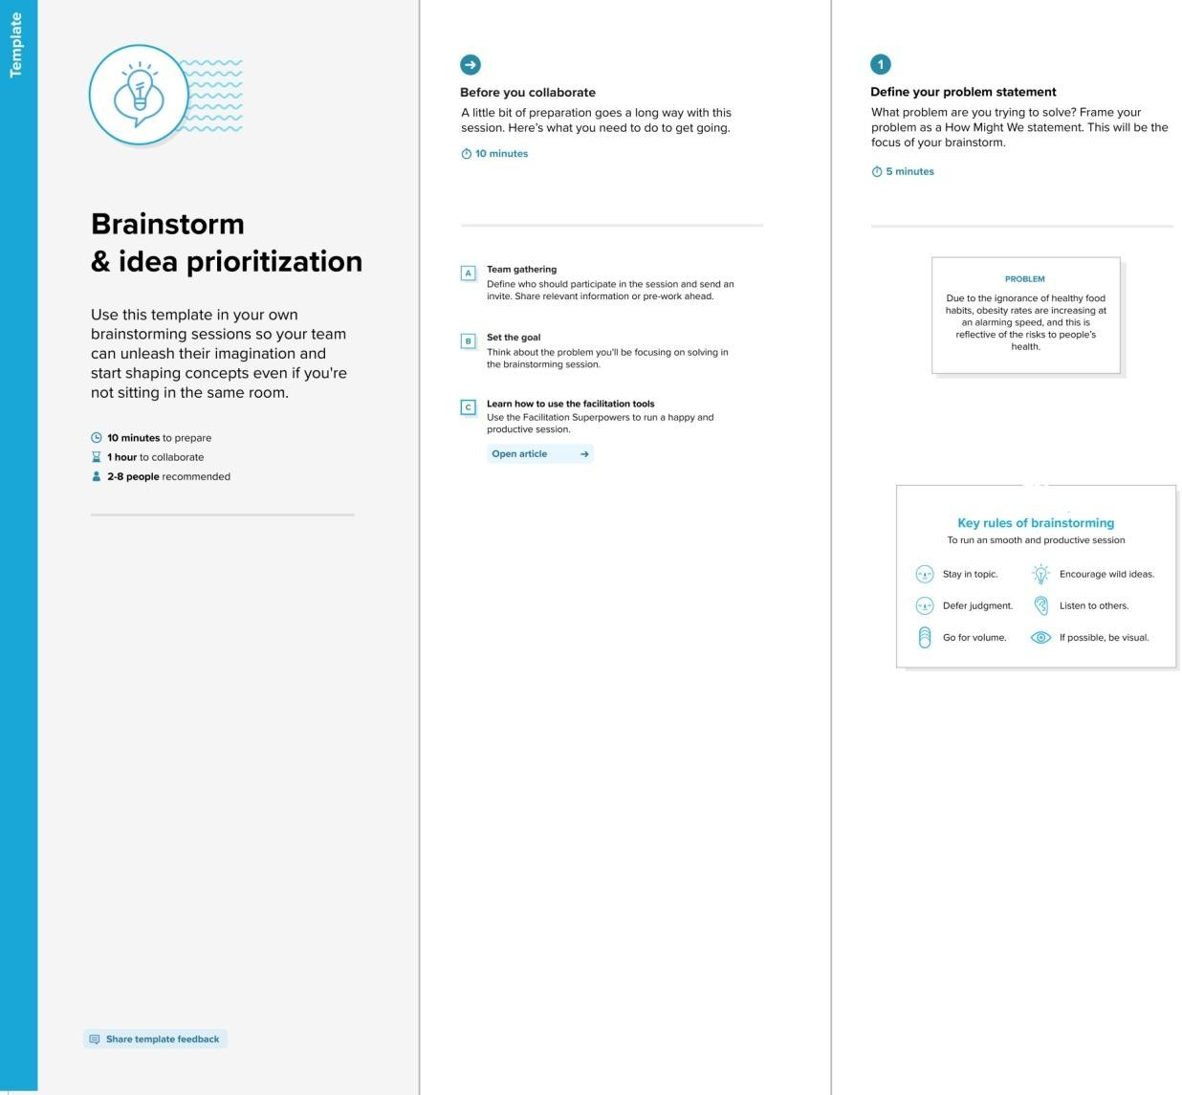

Reference: https://app.mural.co/t/nutritionassistantapplicatio0437/m/nutritionassistantapplicatio0437/ 1663501043399/39fa2b500b62c66287c515ae75e78b1ab6abe30f?sender=ue87679128c86db 7c75c60966

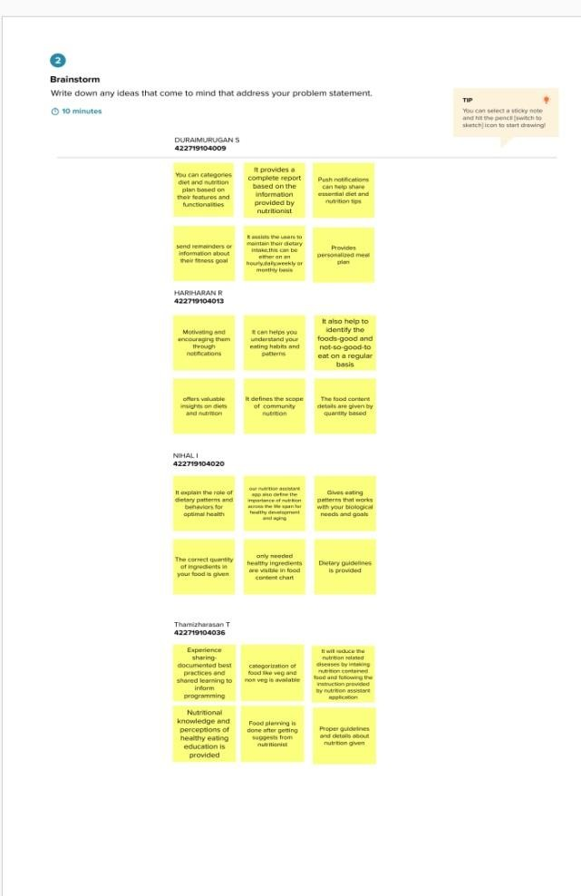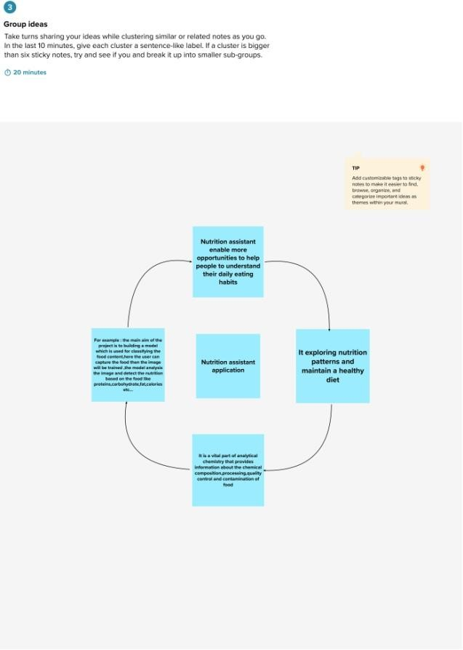**Step-2: Brainstorm, Idea Listing and Grouping**

**Step-3: Idea Prioritization**

